Chapter 17, Solution 82.

P = 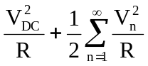

Assuming V is an amplitude-phase form of Fourier series. But

|A_{n}| = 2|C_{n}|, c_{o} = a_{o}

|A_{n}|² = 4|C_{n}|²
Hence,
P = 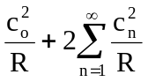
Alternatively,
P = 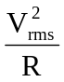
where
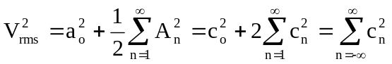

= 10² + 2(8.5² + 4.2² + 2.1² + 0.5² + 0.2²)

= 100 + 2x94.57 = 289.14

P = 289.14/4 = 72.3 W

